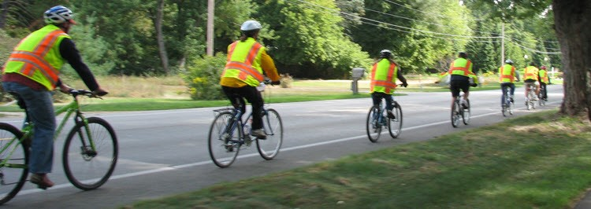

Rural Bikeways Planning and Design
Bicycle Facility Training



Classes: April 10 or 30, 2024
Sessions: 1 - 4 p.m.
This three-hour virtual online course features planning and design approaches for bicycle facilities in a rural context. The program will look deeper into the challenges and solutions for establishing safe and connected bicycle networks within and between rural communities. These concepts will be illustrated using national best practices, case studies, and actual projects in rural communities.


Objectives: Understand special bikeway design considerations in small town, village, rural, and agricultural areas.
Achieve low stress bicycle network planning in rural and small-town contexts. Address connectivity issues between rural and urbanized areas.
Select appropriate bicycle facilities based on context.
Implement appropriate crossing treatments based on roadway characteristics.
Toole Design Group

This course is for village, city, township, county, and Michigan Department of Transportation (MDOT) managers, engineers, planners, and officials; rural and metropolitan planning organization staff; and other stakeholders.

Please RSVP by April 5 for the April 10 class or by April 26 for the April 30 class.
The class link will be provided by a separate e-mail prior to the day of the class.

This course is provided by MDOT. Please use the link below.

Attendees who require mobility, visual, hearing, written or other assistance for effective participation should contact Orlando Curry at 517-241-7462 or CurryO@Michigan.gov, preferably at least 5 business days prior to the scheduled meeting. Forms are located on the Title VI webpage. Requests made after this timeframe will be evaluated and honored to the extent possible.
Experts:

Audience:

Registration:

Registration link for April 10
Registration link for April 30
Accommodation:

